**Annual Report Presentation**

**Presented by**

**Ms. Ranjna**

**Library Intern**

**Indian Institute of Advanced Study Library**

**Shimla**

**Topics of Discussion**

* **SOUL Software**
* **DSpace**
* **Open Journal System (OJS)**
* **KOHA Software**
* **About Digitization**

**SOUL Software**

Software for University Libraries (SOUL) is an state-of-the-art integrated library management software

* It designed and developed by the INFLIBNET Centre
* User-friendly software developed to work under client-server environment
* The latest version of the software i.e. SOUL 3.0 was released in February 2021.
* The database for new version of SOUL is designed for latest versions of MS-SQL and MySQL (or any other popular RDBMS)

**Major Features and Functionalities**

* User-friendly interface
* Compliant to MARC21, AACR-2, MARCXM international Standards
* UNICODE based multilingual support
* Client-server based architecture
* User-friendly OPAC with advanced search facility
* Supports cataloguing of electronic resources
* UNICODE based multilingual support for Indian and foreign languages.
* Compliant to NCIP 2.0 protocol for RFID and other related applications especially for self check-out & check-in
* Supports data exchange through ISO-2709 standard
* online and offline support

**Standard Supported by SOUL Software**

1. The Anglo-American Cataloguing Rules (AACR 2)

2. Common Communication Format (CCF)

3. MARC 21 (Machine Readable Catalogue)

4. ISO 2709

5. NISO Circulation Interchange Protocol

**OS Requirements**

Windows XP SP3, Windows Vista, Windows 2003 Server, Windows 2008 Server.

**Hardware Requirements**

Processor Type: PIV or Higher

Processor Speed: 1.6 GHz or Higher

RAM: Minimum 512 MB (1 GB Recommended)

Free Hard Disk Space: 400 MB (Minimum)

**Modules of SOUL**

* **Acquisition**

The basic purpose of acquisition module is to manage and control the expenditure of funds for materials that meet the collection development criteria of the library**.**

This module enables library staff to handle all the major functions such as

* Suggestion Management
* Order processing , Cancellation and reminders
* Request of document approval,
* Receipt, Payment and budgetary control
* Master files such as currency, vendors, publishers etc.; and
* Report generation

**Working steps of Acquisition module**

Suggestion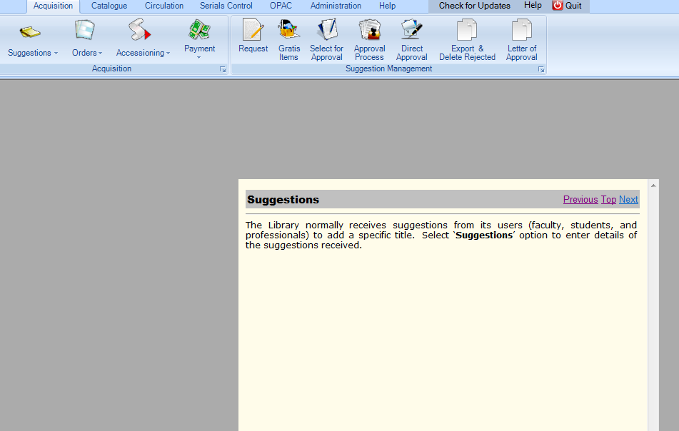order Processing

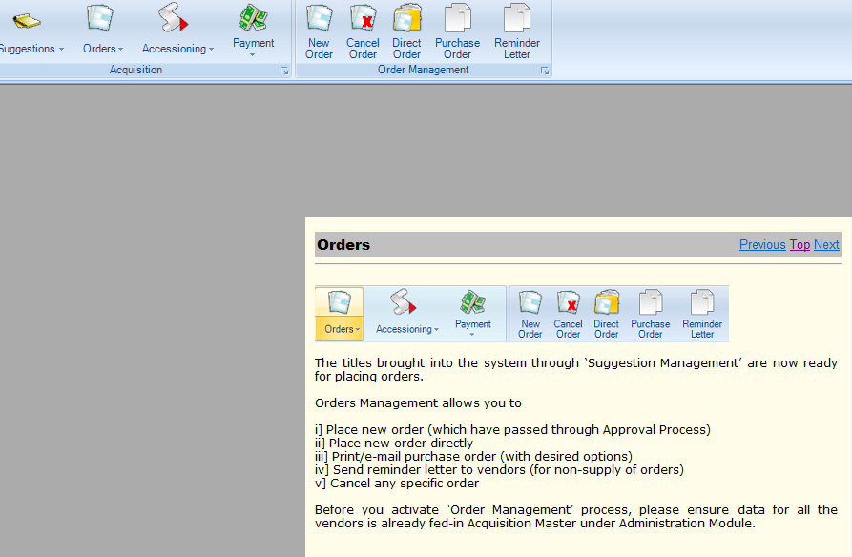

Payment process

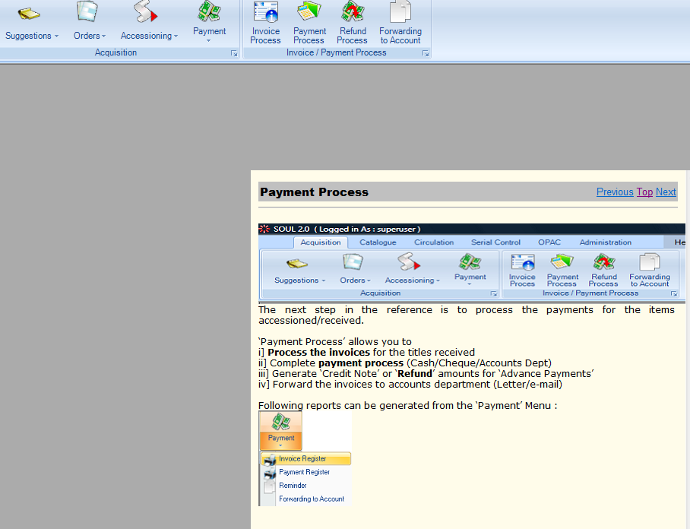

**Cataloguing Module**

Cataloguing module is specially used for database creating of the library resources. It includes following functions

• Allows user generated customized reports.

• Supports copy cataloguing in MARC 21 format by using ISO-2709 Standard.

• Supports of full MARC 21 Bibliographic format. •

* Multi lingual database by using Unicode character set.
* Facilitates authority database of person name, corporate body, subject headings and series name;
* Facilitates generation of spine label barcode and book card

**Main Entry of items**

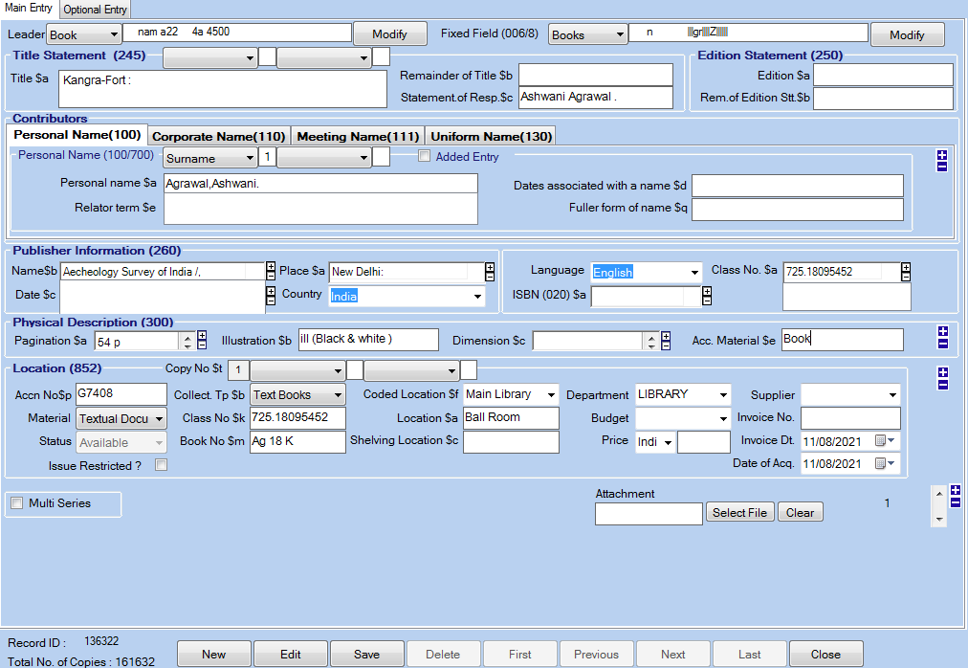

**Optional entry**

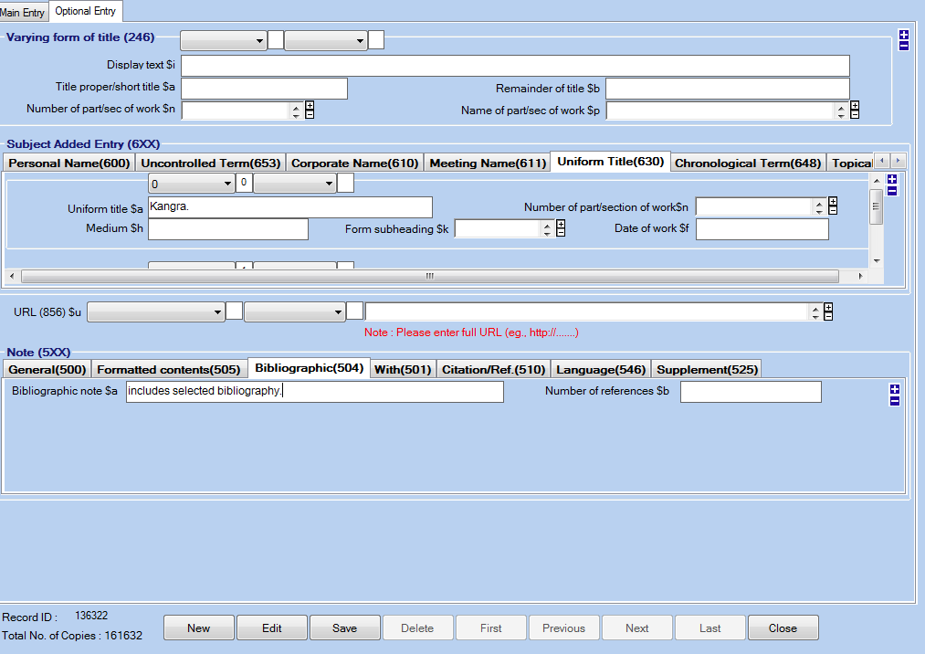

**Circulation Module**

**(**Including issues and discharge, fine collection, reader service, book stock maintenance**)**

Major functions of the circulation module:

• Membership

• Transaction;

• Inter-library loan

• Overdue charges

• Reminder

• Search status

• Maintenance of the items such as binding, lost, replace, missing, etc.

**Membership**

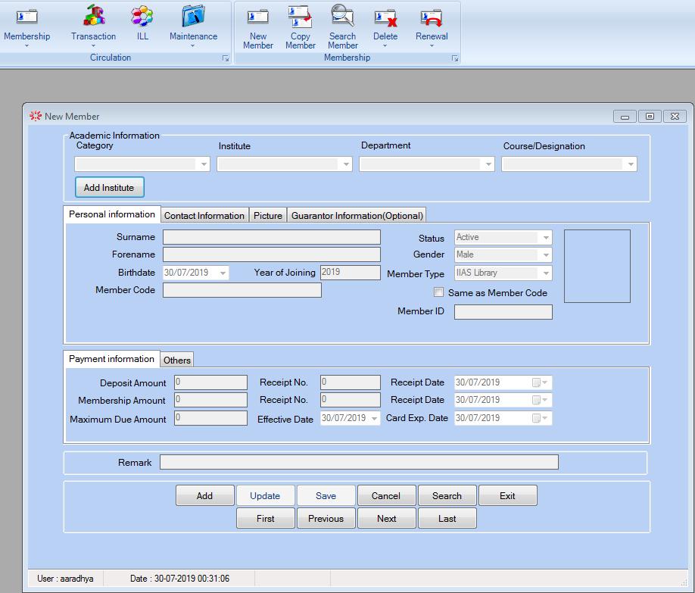

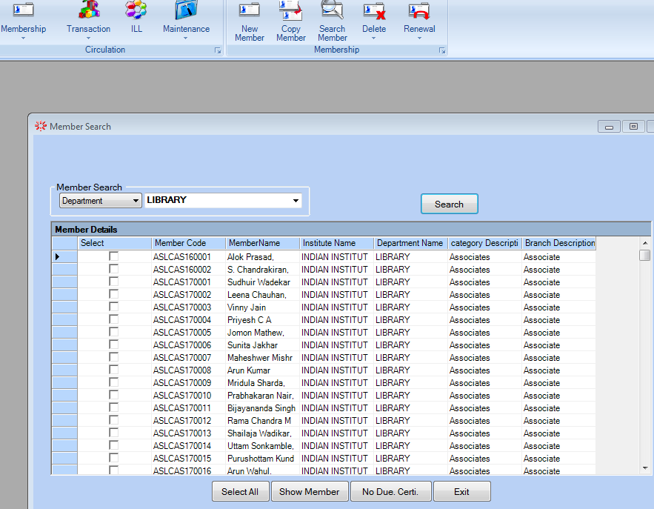

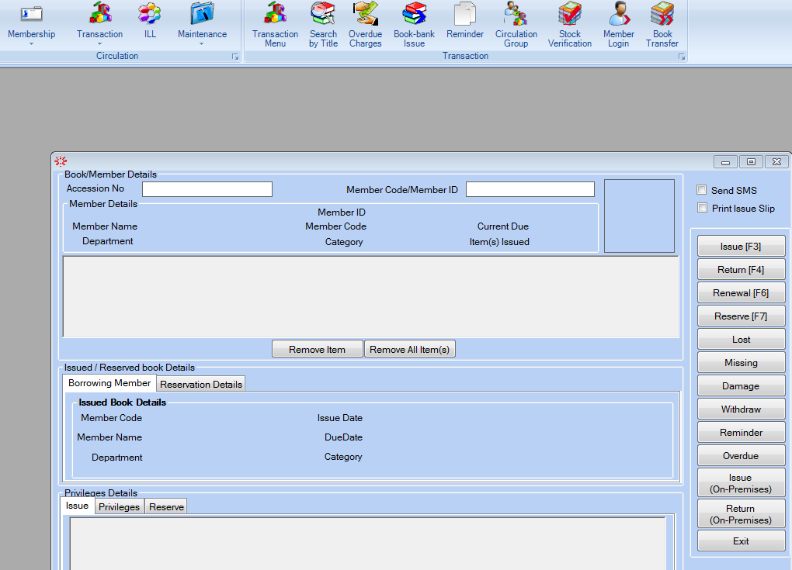

**OPAC Module**

Major functions provided in the module are:

• Simple Search;

• Boolean Search;

• Advanced Boolean Search;

• Displaying and downloading of records in MS Excel, PDF or MARCXML; and

• Search support for the items that are in the acquisition process in the library

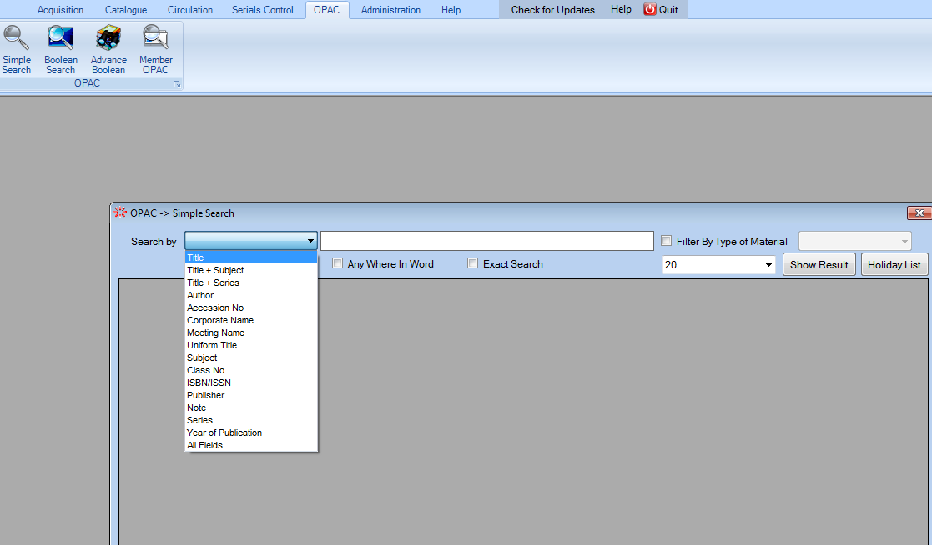

**DSpace Digital Library Software**

An open source repository application that allows you to capture, store, index, preserve and distribute your digital material including text, video, audio and data.

* Designed to help capture and organize everything produced by faculty and staff.
* provides a way to manage your materials and publications in a professionally maintained repository
* Especially designed for digital preservation support for all type of documents.

**History**

• Developed by Hewlett Packard (HP) and Massachusetts Institute of Technology (MIT) in 2002

•2007 HP and MIT form DSpace Foundation, not-for-profit to lead and support users

• 2009 DSpace and Fedora Commons merge, become DuraSpace organization

• Jan 2019 DuraSpace and Lyrasis merge effective July 1, 2019



**Important Features**

* Largest community of users and developers worldwide.
* Free and open source software
* Source code is licensed under BSD open source license
* DSpace is completely customized

Can customize the metadata

Can configure browose and search

* Dspace complies with many standard protocols OAI-PMH, OAI-ORE,SWORD, WebDAV, Opensearch, openURL, RSS ,ATOM
* Configurable database

You can choose either PostgreSQL or Oracle for the database.

* Configure browse and research
* Default language
* Used by many educational, Government, private and commercial institutions.
* Can manage and preserve all the types of digital content.

**Working steps on Dspace**

* Login with your username and password

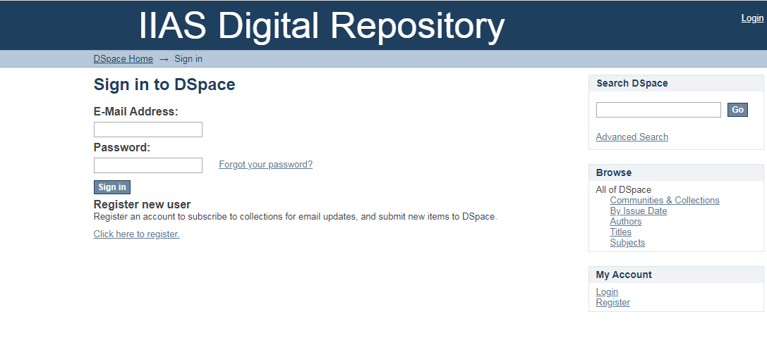This interface will be in front of us

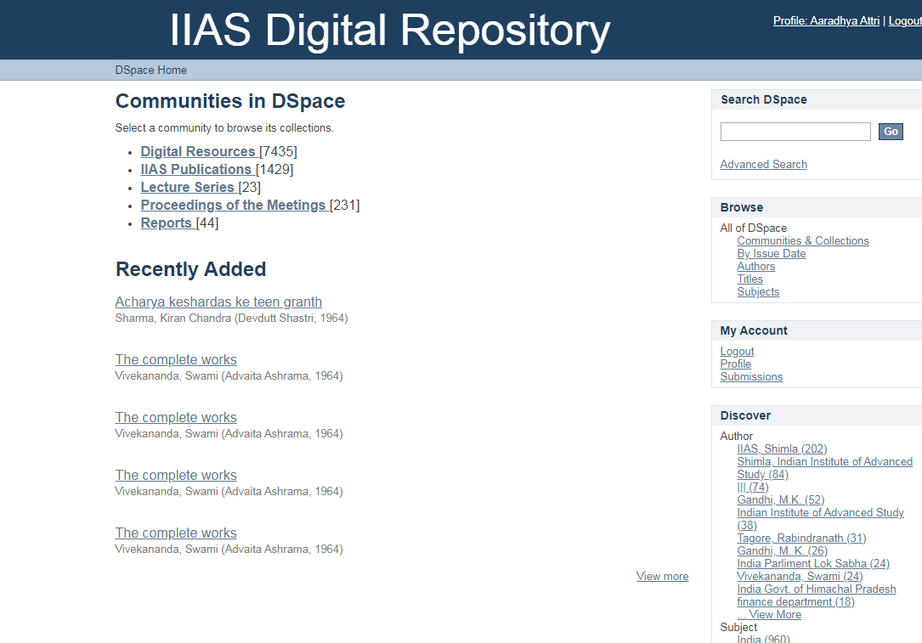

Then we have to select the community where we want to upload the content. Then the interface given below will be in front of us and we have to fill all the necessary fields.

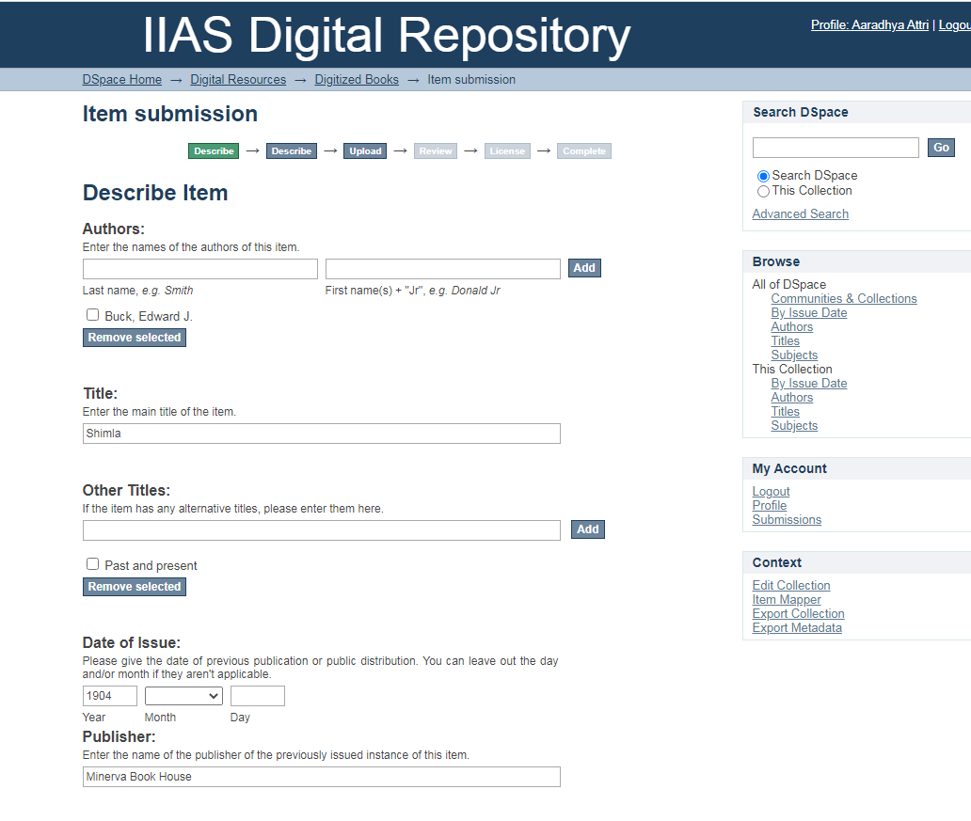

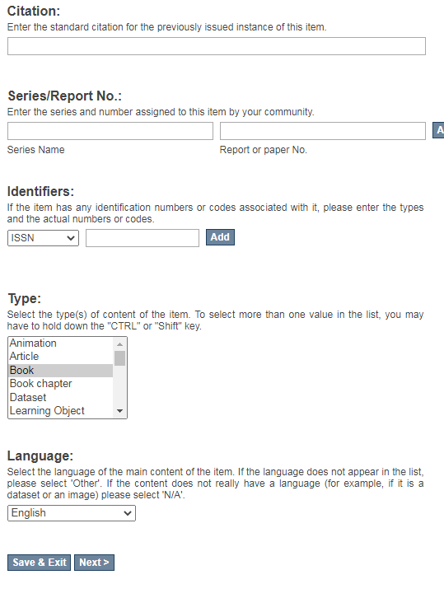

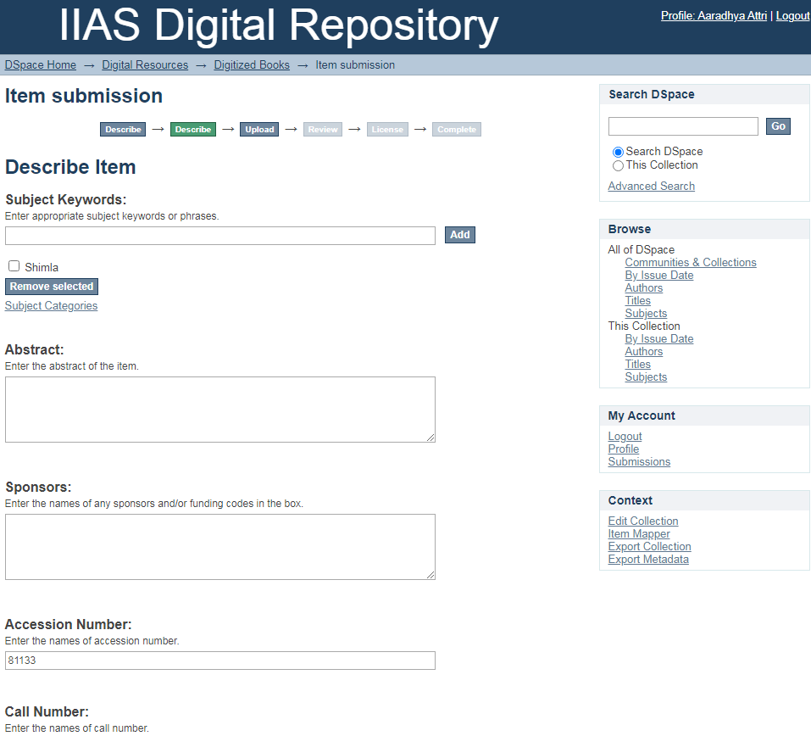

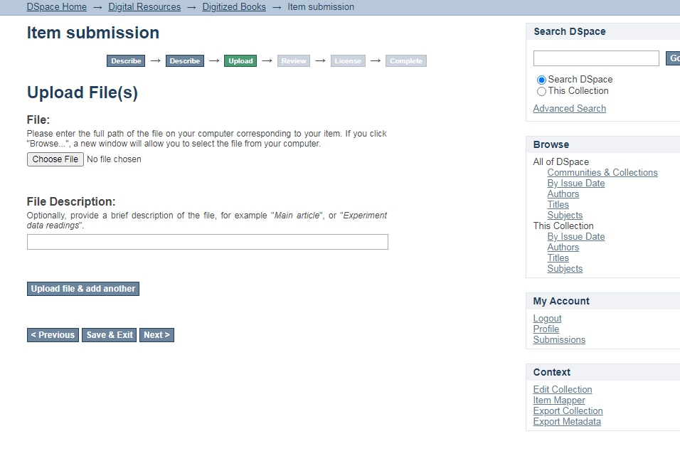

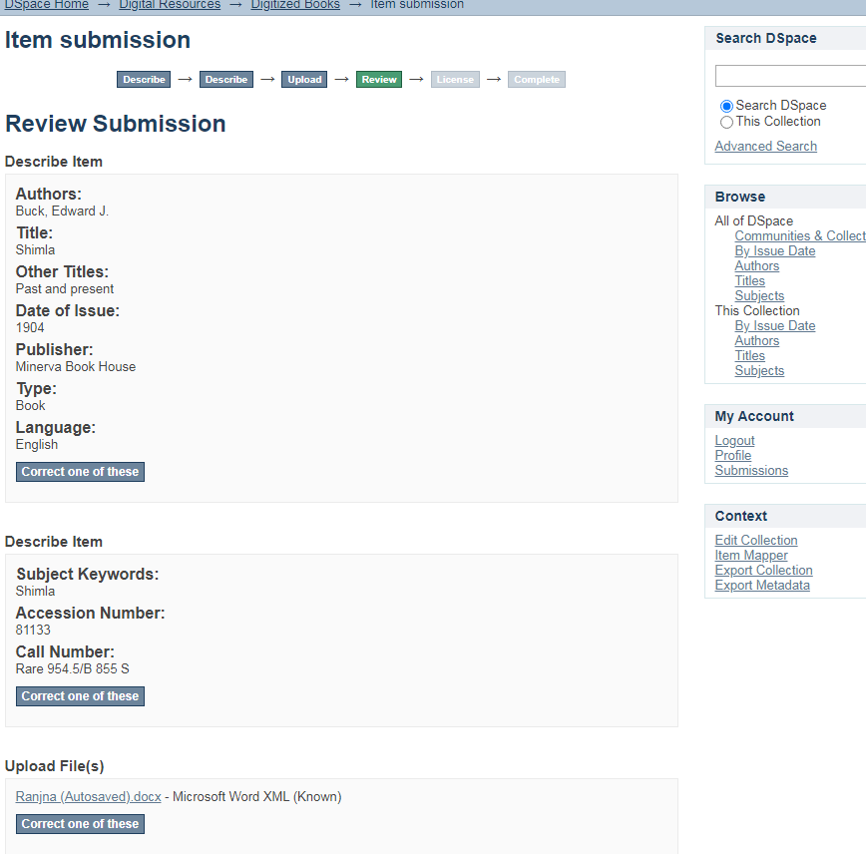

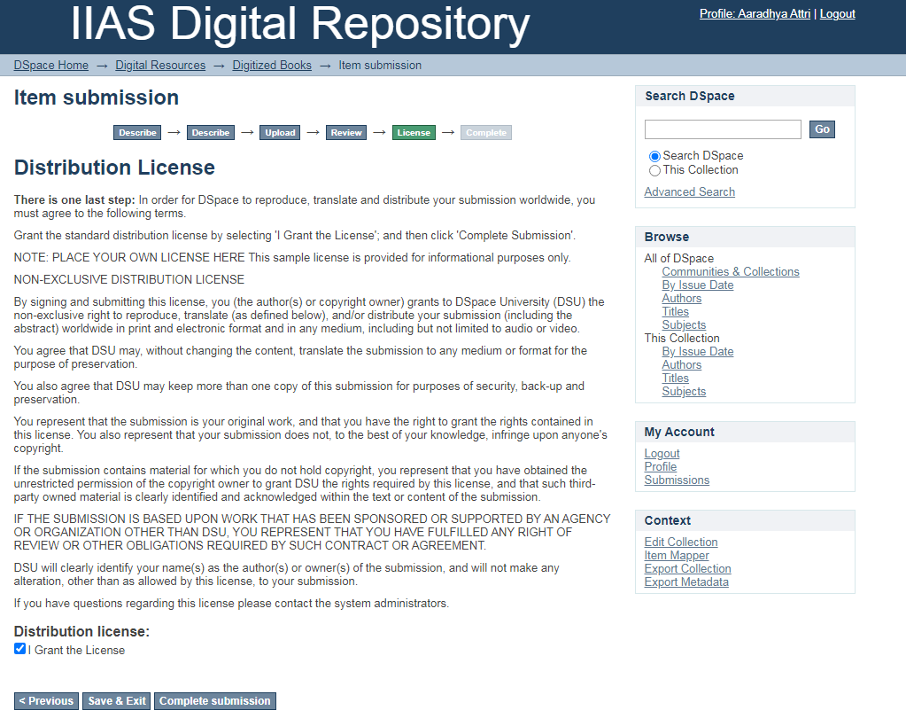The major advantage of the software is that it allows submission of digital documents by its members. Educational institutions dominate in the use of these packages. However, many institutions have implemented digital libraries, but not all are online.

**Open journal System**

Open journal system (OJS) is a software used for the management of open access peer-reviewed journals publishing academic research.

Open Journal Systems is free software for the management of peer-reviewed academic journals. Created by the **Public Knowledge Project**, it is released under the **GNU General Public License**.

* It was developed by "public knowledge project" (PKP) having general public license3.
* It is a very useful journal management system opt by many national and international journals

**Features**

* OJS is installed locally and controlled locally.
* Editors configure requirements, sections, review process, etc.
* Online submission, double-blind review, and management of all content.
* Subscription module with delayed open access and non-open access options.
* Comprehensive indexing of content.
* Reading Tools for content, based on field and editors’ choice.
* Email notification and commenting ability for readers.

**System Requirements**

A server environment meeting the following requirements is recommended:

* PHP support (4.2.x or later)
* MySQL (3.23 or later) or PostgreSQL (7.1 or later)
* Apache (1.3.2x or later) or Apache 2 (2.0.4x or later) or Microsoft IIS 6 (PHP 5.x required)
* Linux, BSD, Solaris, Mac OS X, Windows operating systems

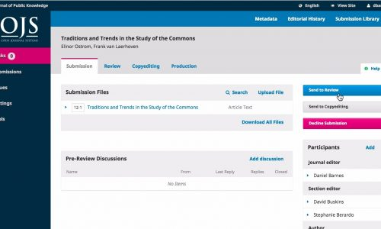

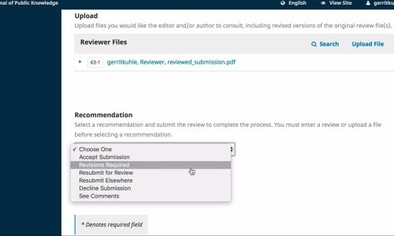

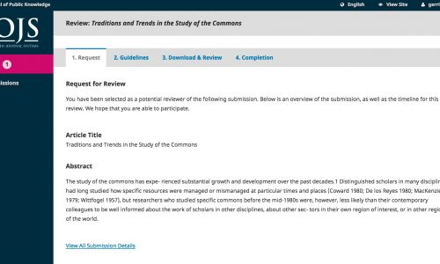

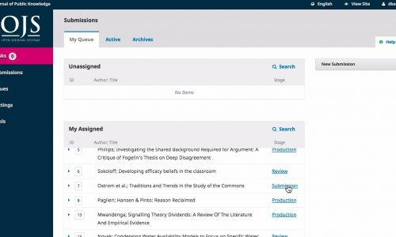

OJS is free and open source software released under the open source GPL v2 license. You are free to download, use, and modify it at no charge. OJS is made freely available to journals worldwide for the purpose of making open access publishing a viable option for more journals, as open access can increase a journal’s readership as well as its contribution to the public good on a global scale.

**KOHA Software**

Koha is a full-featured open-source ILS. It is developed initially in New Zealand by Katipo Communications Ltd. It is currently maintained by a team of software providers and library technology staff from around the globe.

**Operating system**: Linux

**Developer(s)**: Koha Community

**Original author(s):** Katipo Communications

**Stable release**: Koha 21.05.02

**Initial release**: January 2000; 21 years ago

**License**: GPL-3.0-or-later

**Programming languages**: JavaScript, HTML, Perl

**Features**

* Cost-effective
* Innovation
* Free/open source software
* Free/Open source Koha has all the feature of commercial software.
* Proven, Stable Technologies
* Software Collaboration and Resource Sharing:
* Long term support supported by many providers worldwide.
* User-driven:
* Koha is based on a client-server architecture.
* koha can be installed on a server running Linux, Unix, Mac.
* Koha runs over any TCP-IP network.

**Koha Software Requirements**

Application (KOHA)

PHP/PERL

Appache MySQL

Linux (Cent OS)

**Modules of KOHA**

* Acquisition Module
* Serials Module
* Cataloguing Module
* Circulation Module
* OPAC Module
* Members Module

**About Digitization Project of IIAS**

According to Witten and David (2003) defined Digitization as the process of taking traditional library materials that are in form of books and papers and converting them to the electronic form where they can be stored and manipulated by a computer.

**Why digitization**

* To preserve the Documents
* To make the documents more accessible
* To reuse the documents
* Digital materials can be sorted, transmitted and retrieved easily and quickly.
* Access to electronic information is cheaper than its print counterpart

Cornell University Library/Research Departments (2000), provides six stages in digitizing documents for a digital library

• Registering

• Scanning

• Optical Character Recognition,

• Proofreading

• formatting

• producing

• Final Version

For digitization of the documents, we used ScanSnap SV600 software.

* The ScanSnap SV600 is an overhead style contactless scanner that provides a new perspective on document scanning. Unlike the typical scanner, you can easily scan newspapers, magazines, books or documents of up to 30mm thick directly with the overhead LED, without cutting or damaging them.

**Features of ScanSnap SV600**

* Easy scanning for various documents
* Scan important documents without any damage
* Digitize multiple documents at once
* Efficient digital archiving of original digital books.

**Steps for scanning**

Scan with one button!

•Place the book on the mat and press the scan button.

•Page Turning Detection: SV600 detects when a page is turned and automatically begins scanning.

•Time Mode: Set a fixed time interval and SV600 scans in real time with you.

**Auto Image Correction**

Auto Image Correction: Automatically crops, de-skews and sets the orientation of multiple sheets placed on the mat.

**System Requirements**

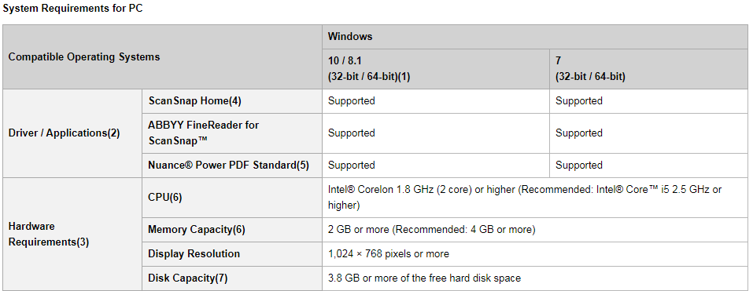

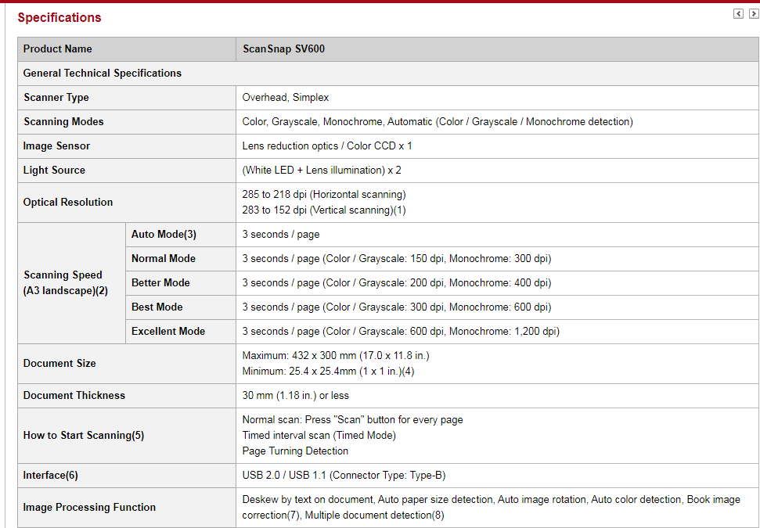

Libraries around the world have been working on digitization of their libraries now and IIAS Library is one of them. They have created many digital library initiatives and projects. As with most other technical developments in libraries over the years, we will have to move forward in small, manageable, evolutionary steps, rather than in a rapid revolutionary manner.

**Conclusion**

The main purpose of the library is to fulfil academic and research needs of its users community through acquiring standardized information resources and disseminating those resources to the right user through appropriate information services.

The IIAS Library offers internship program on library education for creating potential skilled library professionals. So it’s great apportunity for library science students to join internship program in IIAS Library, and earn practical knowledge about library.

This practical experience will helps a great deal when Library science students will found themselves in the Library and Information Science profession.

**References**

1. [**https://www.academia.edu/19144649/Internship_report_on_Dhaka_University_Library**](https://www.academia.edu/19144649/Internship_report_on_Dhaka_University_Library)
2. **https://corescholar.libraries.wright.edu/cgi/viewcontent.cgi?article=1073&context=irday**
3. [**https://www.slideshare.net/mehedidu50/an-internship-report-on-library-operations-and-services-of-du**](https://www.slideshare.net/mehedidu50/an-internship-report-on-library-operations-and-services-of-du)
4. [**https://soul.inflibnet.ac.in/features.php**](https://soul.inflibnet.ac.in/features.php)
5. [**https://en.wikipedia.org/wiki/Open_Journal_Systems**](https://en.wikipedia.org/wiki/Open_Journal_Systems)